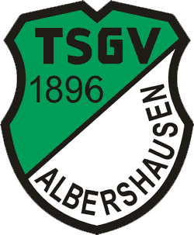

First Mäußnest Acro-Cup
13. – 16. April 2023
Sporthalle Albershausen
Schulstrasse 33
Germany

Please sent the form to:
Organizing Committee / Host Federation
Sportakrobatik TSGV Albershausen

e-mail: acrocup@gmail.com
Deadline: 25. January 2023
VISA REQUEST Form

Federation / Club |  |  |  | Contact person:
Federation / Club |  |  |  | Phone:
Federation / Club |  |  |  | E-mail:
First name | Last name | Function | Gender  M/F |  | Date of birth  dd.mm.yyyy | Citizenship and  passport No. | Passport expiry date | Arrival date | Departure date | City*
* city where the visa application support letter must be sent to
Place and date | Seal of the NF | NF authorised signature
Please fill it out with the computer and not by one's own hand. Thank you!

